  - 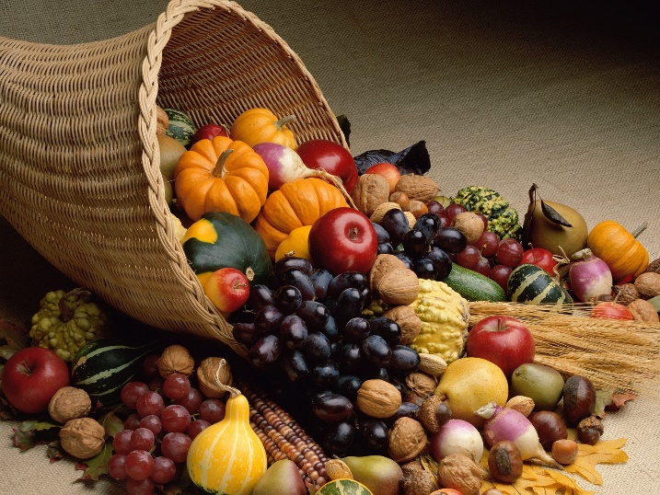

  - This week’s meditation includes scripture from the book of Joel. This passage was written during a very hard time in the history of the Hebrew people. There hadn’t been rain in ages and so the crops were very poor as they shriveled up from lack of moisture.
As if dying crops weren’t bad enough, along came swarms of grasshoppers that managed to devour what little grain was left.
Yet, in the midst of the threat of famine and destruction, people sang a song of thanksgiving, trusting that rain would eventually come and that God would continue to look after and care for all of them.
They sing a song of praise as if the rains they long for have already come. Indeed, this is a true thanksgiving.
These words of thanksgiving can remind us today, when we may be going through times of great anxiety and worry, that God continues to be at work in the world.
Joel 2: 21-27 (Common English Bible)
Don’t fear, fertile land; rejoice and be glad, for the Lord is about to do great things! Don’t be afraid, animals in the field, for the meadows of the wilderness will turn green; the tree will bear its fruit; the fig tree and grapevine will give their full yield.
Children of Zion, rejoice and be glad in the Lord your God, because he will give you the early rain as a sign of righteousness; he will pour down abundant rain for you, the early and the late rain as before.
The threshing floors will be full of grain; the vats will overflow with new wine and fresh oil.
I will repay you for the years that the cutting locust, the swarming locust, the hopping locust, and the devouring locust have eaten—my great army, which I sent against you.
You will eat abundantly and be satisfied, and you will praise the name of the Lord your God, who has done wonders for you; and my people will never again be put to shame.
You will know that I am in the midst of Israel, and that I am the Lord your God—no other exists; never again will my people be put to shame.
Truly these words can remind us that in the most difficult and trying times, God is with us, guiding and sustaining us. So, let us offer thanks to God who walks with us always.
Happy Thanksgiving
Pastor Diane

