**January 5, 2025**

**Second Sunday after Christmas**

**Communion**

**All that we are, all that we have,**

**and all that we will become is a gift from God.”**

*\*Indicates all who can, please stand.* **Bold print invites all to speak or sing!**

**Gathering Music “Slumber Song” Schumann**

* **Call to Worship (responsive)**

In the beginning was the Word;

**The Word was in God’s presence and the Word was God.**

The Word was present to God from the beginning. Through the Word all things came into being….

**In the Word was life and that life was humanity’s light….**

And the Word became flesh and stayed for a little while among us;

**We saw the Word’s glory…**

The favor and position a parent gives an only child…

**Filled with grace, filled with truth.**

Let us rejoice in the Word!

**\*Opening Hymn: “Angels, from the Realms of Glory” No. 149**

**\*Unison Prayer**

**O Word made flesh; you have come into our midst as light and wisdom, desiring to be known to us in our lives and to be found in the world around us. Open our eyes and our hearts to recognize where you dwell—in our midst—challenging, heartening, lighting the way to truth, peace and justice. Amen.**

**\*Prayer of Confession**

**Holy God, we confess that we are distracted and forgetful of your love. We make selfish choices. We hurt each other. We ask your forgiveness for all those times we disregard you, each other and your creation. Restore us we pray, teach us to live in your light and walk in your truth. Amen.**

**\*Words of Assurance**

**\* Gloria Patri** No. 35

*Please Be Seated*

**The Choir Sings:**

**Scripture Readings: John 1: 1-9 Luke 2: 41-52**

**Morning Message: “Left Behind’**

**Dedication Hymn: “It Came upon the Midnight Clear” No. 153**

**Sharing our Joys and Concerns**

**Pastoral Prayer**

**Lord’s Prayer**

**Presenting our gifts**

**\* The Doxology**

**\*The Dedication Prayer**

**With these gifts, dear God, accept the praise and thanksgiving of our hearts, which rejoice in your goodness and love. Let our gifts point to your presence in the world and further your dream for the world. Amen.**

**\* Communion Hymn: “I Wonder as I Wander" No. 161**

**Invitation to Communion**

**Words of Institution, Consecration, Sharing the Elements**

**\*Prayer of Thanksgiving**

**\*Consecration Hymn: “Good Christian Friends, Rejoice” No. 164**

**\* Benediction**

**God, giver of joy, we thank you for meeting us here in the child born to save us. You have prepared us for our journey. The light of Christ, shining like a star shows us the way we should go and the ones we should serve. May our faces, lifted up in wonder and expectation, reflect that light for all who live in darkness. Amen.**

**Postlude: “To Bethlehem on Christmas Morn” Handel**

*Our Annual Congregational Meeting will be held following worship on Sunday, January 19.*

*Attendance for Dec. 29th was 21 adults.*

*Just a reminder: Please silence or turn off your cell phones during worship.*

*Pastor Diane Thomas*

*Pastor Phone: (928) 642-6676*

*Church Phone: (419) 683-2745*

*Pastor email:* [*dsthomas18@ymail.com*](mailto:dsthomas18@ymail.com)

*Church email:* [*crestlinecalvary@gmail.com*](mailto:crestlinecalvary@gmail.com)

*The church website:* [*www.crestlinecalvary.com*](http://www.crestlinecalvary.com)

*You may view our worship service on our website.*

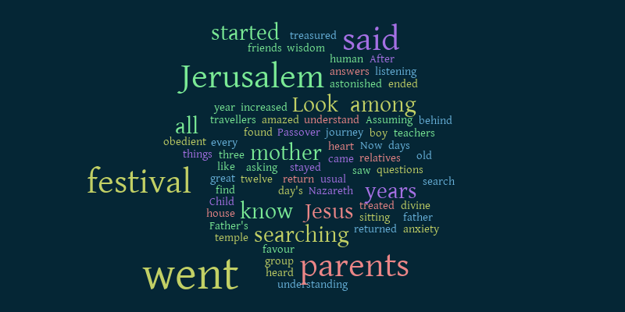

***Welcome to Calvary***

***United Church of Christ***

**January 5, 2025**

**Second Sunday after Christmas**

**Communion**

**“Serving God and Crestline Since 1859”**

**We welcome you and thank you for joining in worship!**