January 12, 2025
First Sunday after Epiphany
Baptism of Christ
All that we are, all that we have,
and all that we will become is a gift from God.”
*Indicates all who can, please stand. Bold print invites all to speak or sing!

Gathering Music “Allegro” Corelli

*Call to Worship (responsive)
Come, all God’s people and listen to the voice of God.
God’s voice is in the murmur of the waters.
The water is cleansing and refreshing.
Water reminds us of our vows to follow Christ.
Baptism clears a way for new life.
Baptism reminds us that we are God’s people and that we join together in love and service.

*Opening Hymn: “Christ Is Made the Sure Foundation” No. 275

*Unison Prayer (responsive)
From the formless waters God created life and called them good.
In the waters of the river Jordan, John baptized Jesus, the source of living
water.
Christ invites all who thirst to come and drink.
Our baptism with water is a symbol of our covenant with Christ.
It reminds us that we too shall welcome all to the living water.
Come all; prepare your hearts and minds to drink the living water.

*Prayer of Confession
Gracious God, in our busy lives, it’s too easy to get caught up in what we are doing, saying, expecting. We confess that we seem to have time for everything except prayer and service. Forgive us. Help us to find your presence and your peace. Give us the wisdom we need to live in these busy days.
Amen.

*Words of Assurance

* Gloria Patri No. 35
Please Be Seated

The Choir Sings: “The Holly and the Ivy”

Scripture Readings: Isaiah 43: 1-7 Luke 3: 15-17, 21-22
Morning Message: “God on the Loose”’
Remembering and Renewing our Baptism
Introduction, Vows of Renewal

Do your renew and affirm the promises made at your baptism?
I do.
Do you recognize the call of God to be God’s people always?
I do.
Do you embrace the way of Jesus in faith and ministry?
I do.
Do you accept the nurture of the Holy Spirit who renews your spirit everyday?
I do.
Do you accept and embrace others who seek a liberating faith in God?
I do.
In renewing your baptismal vows, remember your baptism as a mark of acceptance and welcome into the care of Christ’s church where you may begin again your Christian faith and love.

Unison Prayer:
O God, we rejoice in your grace, given and received. We thank you that you claim us, that you strengthen us and guide us, that you empower us to live a life worthy of our calling. In the way of Jesus, make us as water in a dry and thirsty world. Root us and nurture us in love, that with all your people we may serve you. Fill us with your fullness that our lives may overflow in service and love. Amen.

Dedication Hymn: “Jesus Calls Us O’er the Tumult” 337

Sharing our Joys and Concerns
Pastoral Prayer
Lord’s Prayer

Presenting our gifts
* The Doxology

*The Dedication Prayer
Loving God, we offer you all that we are—our strengths and weaknesses, our hopes and fears, our desires and dreams—along with these gifts. Accept what we bring in Christ’s name. Amen.

*Closing* Hymn: “Love Divine, All Loves Excelling” No. 517

* Benediction
God has called each of us by name.
We are yours, O God.
Do not fear, God goes with you wherever you may go.
We are yours, O God.
Even when you pass through rough waters, God will be with you.
We are yours, O God.
Go in peace to love and serve God.
Amen.

Postlude: “Andante Cantible” Widor

Attendance for Jan.5th was 18 adults.

Our Annual Congregational Meeting will be held following worship next Sunday, January 19.

Just a reminder: Please silence or turn off your cell phones during worship.
Pastor Diane Thomas
Pastor Phone: (928) 642-6676
Church Phone: (419) 683-2745
Pastor email: dsthomas18@ymail.com
Church email: crestlinecalvary@gmail.com
The church website: www.crestlinecalvary.com
You may view our worship service on our website.

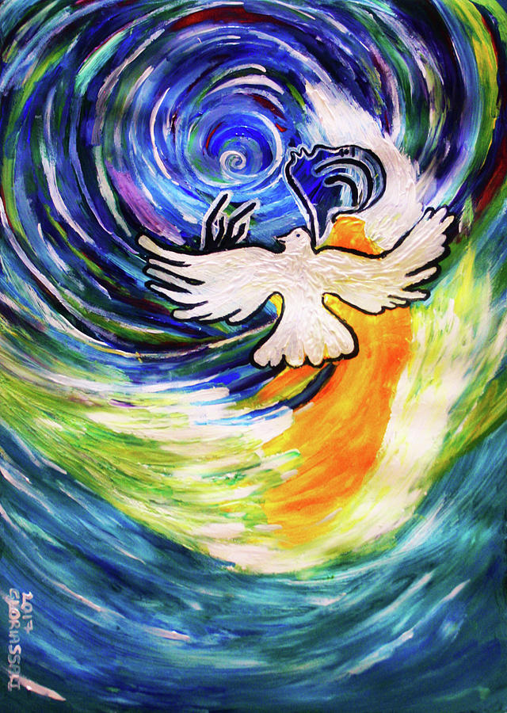

Welcome to Calvary
United Church of Christ
January 12, 2025
First Sunday after Epiphany
Baptism of Christ
“Serving God and Crestline Since 1859”
We welcome you and thank you for joining in worship!

