January 19, 2025
Second Sunday after Epiphany
Annual Congregational Meeting
All that we are, all that we have,
and all that we will become is a gift from God.”
*Indicates all who can, please stand. Bold print invites all to speak or sing!

Gathering Music “Glorious Things of Thee Are Spoken” Hayes

*Call to Worship (based on 1 Corinthians 12: 1-11 (responsive)
There are a variety of gifts, but the same Spirit.
God’s gifts overflow on us.
There are varieties of services, but the same Lord.
God’s gifts overflow on us.
There are a variety of activities, but it is the same God who activates all of them in everyone.
Let us worship the God from whom we have received overflowing gifts!

*Opening Hymn: “All People That on Earth Do Dwell” No. 18

*Unison Prayer
Gracious God, you have given each one of us special gifts—gifts from your Spirit. We praise you, God, for the gifts that overflow in us. Help us to know how you want us to use our gifts, for ourselves and our community. Be with us today as we sing praises, hear your word and open our hearts to the ways you are speaking to us and through us. Amen.

*Prayer of Confession
Forgive us, God when we fail to recognize the gifts you have given, when we look at the gifts of others and wish they were our gifts, when we think our gifts aren’t good enough, when we see the needs around us but don’t think there’s anything we can do, when our fears keep us from helping others. Forgive us merciful God. Teach us that we have enough, for ourselves and for others. Amen.

*Words of Assurance

* Gloria Patri No. 35
Please Be Seated

The Choir Sings: “Be Strong in the Lord”

Scripture Readings 1 Corinthians 12: 1-11 John 2: 1-11

Morning Message “Always Enough”

Dedication Hymn: “In Christ There Is No East or West” No. 687

Sharing our Joys and Concerns
Pastoral Prayer
Lord’s Prayer

Presenting our gifts
* The Doxology

*The Dedication Prayer
Loving God, whose gifts are over flowing: as you have poured out love upon your people, so we seek to give back to you even a little of all you have given us. Take and use the gifts you have entrusted to us and which we now offer back to you, that we in turn might overflow with love for your world. Amen.

*Closing Hymn: “Lord, I Want to Be a Christian” No. 589

* Benediction
God has blessed us with an abundance of life. God’s promise for the world is filled to the brim
and overflowing.
God has blessed us with an abundance of hope. God’s world is filled to the brim.
and overflowing.
God has blessed us with an abundance of truth. God’s truth for the world is filled to the brim.
and overflowing.
Go and offer the world, God’s abundant gifts, for there are more than enough. God’s love for the world is filled to the brim
and overflowing. Amen.

Postlude: “Immortal, Invisible” Welsh Melody
This morning following worship, everyone is invited to remain in the sanctuary for our Annual Congregational Meeting.

Attendance for Jan. 12th was 20 adults.

Just a reminder: Please silence or turn off your cell phones during worship.

Pastor Diane Thomas
Pastor Phone: (928) 642-6676
Church Phone: (419) 683-2745
Pastor email: dsthomas18@ymail.com
Church email: crestlinecalvary@gmail.com
The church website: www.crestlinecalvary.com
You may view our worship service on our website.



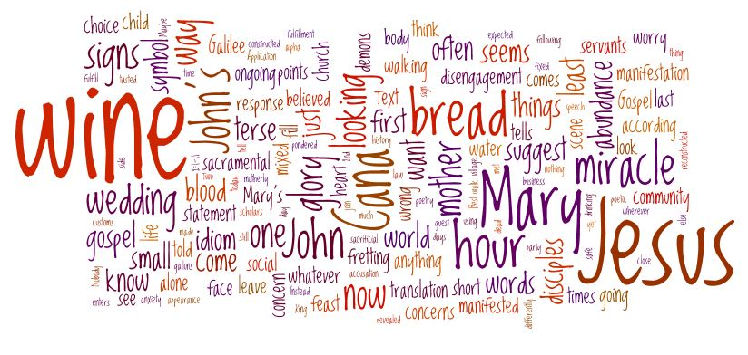
Welcome to Calvary
United Church of Christ
January 19, 2025
Second Sunday after Epiphany
Annual Congregational Meeting
“Serving God and Crestline Since 1859”
We welcome you and thank you for joining in worship!

