  - 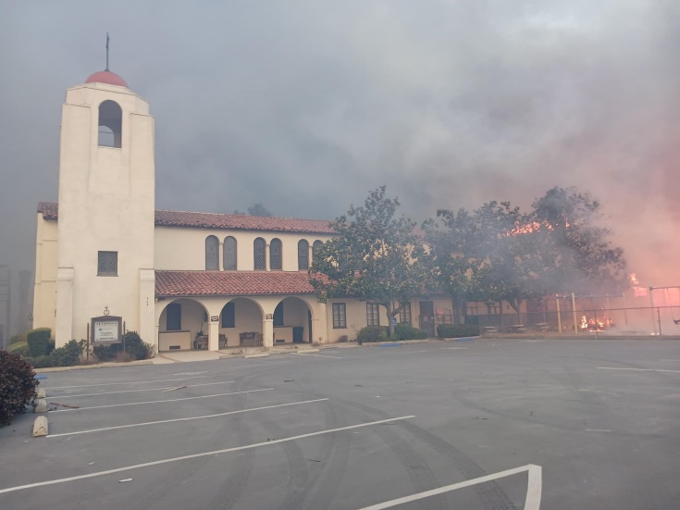
Altadena Community Church, United Church of Christ
We’ve all seen images like this and heard the stories about the losses suffered by the residents of the Los Angeles area in California.
Rev. Kent Siladi, Interim Director of Philanthropy has written this. “The devastation caused by the California wildfires has left countless families without homes, communities in mourning and landscapes forever changed. As the smoke clears, the work of recovery begins—and it’s a long road ahead.
Rev. Rachael Pryor, Conference Minister of the Southern California Nevada Conference, United Church of Christ tells us: “We listen to the howling winds at night and wonder, Is this going to be the gust that will ignite an ember? We don’t know what to expect, except that this is far from over. Unlike a hurricane or tornado which eventually ends, the ongoing fear of where the flames will sweep through next is creating a deep trauma.”
As always, when disaster strikes, the United Church of Christ responds. Together we can show God’s love in action.
Indeed, our congregation has an opportunity to help the victims of these wildfires as people try to find ways to “re-group” and move on. Help is needed not only right this minute, but in the long term as well.
Re-building will take a long time. The United Church of Christ Disaster Response Team is committed to providing help now and on into the future.
Over the next few weeks, we will have special offering envelopes for donations to this recovery and re-building effort. Please indicate on your check, “wildfire relief.”

All donations will go directly to this relief effort. Every gift matters.
Rev. Shari Presermon of the United Church of Christ writes: “But there ways we can meaningfully and appropriately respond now, by giving generously to support recovery needs and by keeping all who are heartbroken and fearful in our steadfast prayers. Our response as the Body of Christ, now and over many months and years to come, can truly have a powerful impact.”
We can stand with California communities during this time of extreme hardship. Your generosity will make a difference.
Blessings and Peace,
Pastor Diane

